**Steps to setup Ansible for Controller**

**1) Setup ssh for password-less authentication**

a) $ ssh-keygen -t rsa -N "" -f ansibleServer_ssh_key

This generates ansibleServer_ssh_key and ansibleServer_ssh_key.pub with no passphrase.

Copy ansibleServer_ssh_key to ansibleServer_ssh_key.pem

Move ansibleServer_ssh_key.pub and ansibleServer_ssh_key.pub to ~/.ssh folder

b) $ ssh-copy-id -i ~/.ssh/ansibleServer_ssh_key.pub vbcpe@10.5.5.31

replace vbcpe@10.5.5.31 with username@A.B.C.D of the device on which the controller will be setup.

c) Check for password-less connectivity

$ ssh -i ~/.ssh/ansibleServer_ssh_key.pem username@A.B.C.D

**2) Install ansible as below : -**

$ sudo apt-get install software-properties-common

$ sudo apt-add-repository ppa:ansible/ansible

$ sudo apt-get update

$ sudo apt-get install ansible

Add the IP address of the host (controller) in /etc/ansible/hosts as below

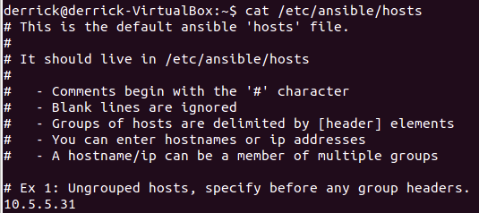

a) Check for ansible connectivity using

$ ansible all -m ping -u vbcpe -vvvv --private-key ~/.ssh/ansibleServer_ssh_key.pem

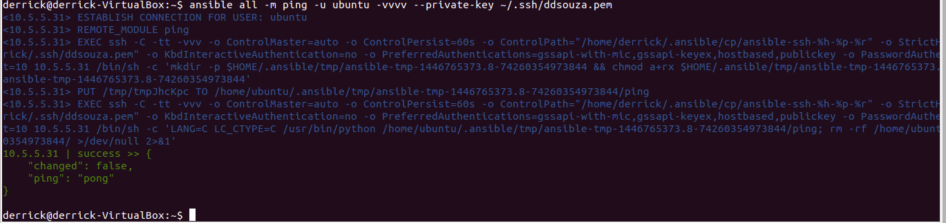

**3) Running ansible from the remote server**

The --ask-become-pass is needed for commands needing root privileges. Enter the root password whenever prompted.

Use the below following order to run the ansible scripts.

$ ansible-playbook ~/Downloads/ansibleDemo/env1.yml -u username -vvvv --private-key ~/.ssh/ansibleServer_ssh_key.pem --ask-become-pass

$ ansible-playbook ~/Downloads/ansibleDemo/jtm1.yml -u username -vvvv --private-key ~/.ssh/ansibleServer_ssh_key.pem --ask-become-pass

$ ansible-playbook ~/Downloads/ansibleDemo/jtm2.yml -u username -vvvv --private-key ~/.ssh/ansibleServer_ssh_key.pem --ask-become-pass

$ ansible-playbook ~/Downloads/ansibleDemo/buildLsoapi.yml -u username -vvvv --private-key ~/.ssh/ansibleServer_ssh_key.pem --ask-become-pass

$ ansible-playbook ~/Downloads/ansibleDemo/tomcat.yml -u username -vvvv --private-key ~/.ssh/ansibleServer_ssh_key.pem --ask-become-pass

$ ansible-playbook ~/Downloads/ansibleDemo/controller.yml -u username -vvvv --private-key ~/.ssh/ansibleServer_ssh_key.pem --ask-become-pass

NOTE: All yml ansible scripts as well as Ubuntu scripts can be found at <https://community.cablelabs.com/wiki/display/VCPE/Controller+Laptop+Setup>

You can contact me anytime for troubleshooting.

My personal contact details --

Derrick D’souza

E-mail address – derrick.dsouza@colorado.edu / derrick.dsouza28@gmail.com

Cell – (720) 519 - 9160